CS 340 README

About the Project/Project Title
Built using pymongo, CRUD Python Module serves as a glue between MongoDB databases and web software.

Motivation
CRUD Python Module seeks to simplify CRUD function calls for web apps and act as a protective layer for the underlying database. This was made specifically for Grazioso Salvare but can be easily repurposed for other databases.

Getting Started
CRUD Python Module is simple to get started. As the user, simply download the files and import them to your project.
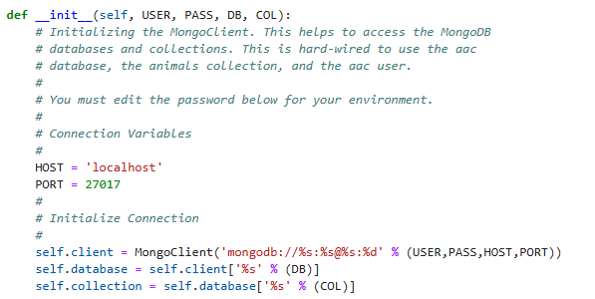
The class expects a username, password, database name and collection name as parameters. So please include them in your instantiation of the class.
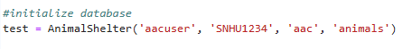
The create and read functions were created based on MongoDB documentation and PyMongo tutorials and were fairly simple to create. Each function has been optimized to work regardless of the database, despite the class name.

Installation
This module relies on PyMongo and objectId to function. PyMongo is the official MongoDB driver in Python and provides the basis for all CRUD functionality within with app, while objectId allows for use of the objectId type, which MongoDB uses for unique IDs. All the user needs is Python, as both requirements are already installed to the module.

Usage

Code Example
The module contains four functions, create, read, update, and delete
create takes the input of a dictionary and inserts it into the configured database, returning True if the insert was successful and False if not.
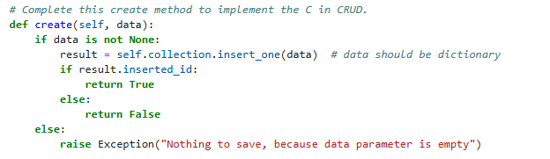
Use Example:
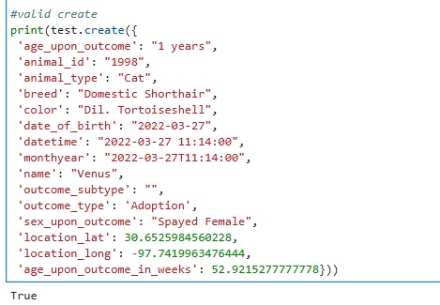

read takes the input of a dictionary, finds the matching document and prints it for the user.
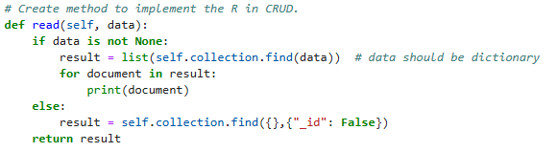

Use Example:
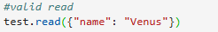
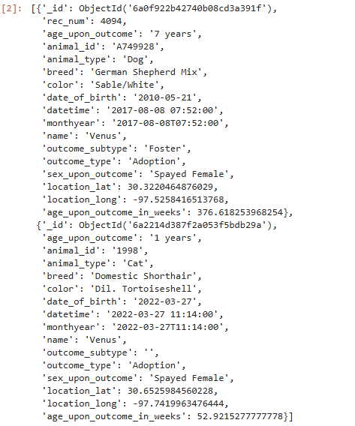

update takes two dictionary arguments, using the first to find one or more documents and the second as the update operation, updates all matching documents then returns the number of documents updated. Note that a MongoDB operator, such as ‘$set’ must be used to update a specific cell, rather than replacing the document.
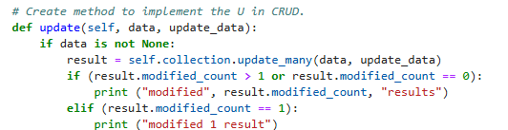

Use Example:
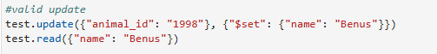

delete takes the input of a dictionary, finds one or more matching documents, deletes them, then returns the number of documents deleted.

Use Example:
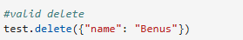

Tests
So far, I have only tested for basic functionality and shown that the module works with the configured animal shelter database. Here is an example of inserting an instance of a cat document into the database, reading it, updating it, then deleting it.

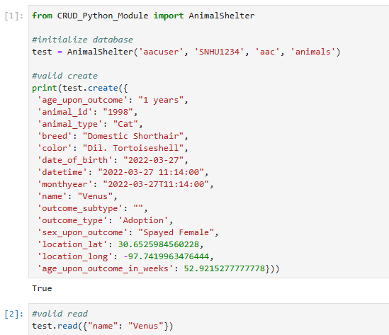
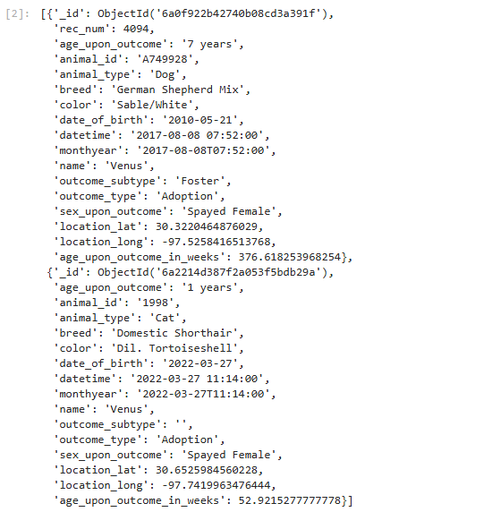
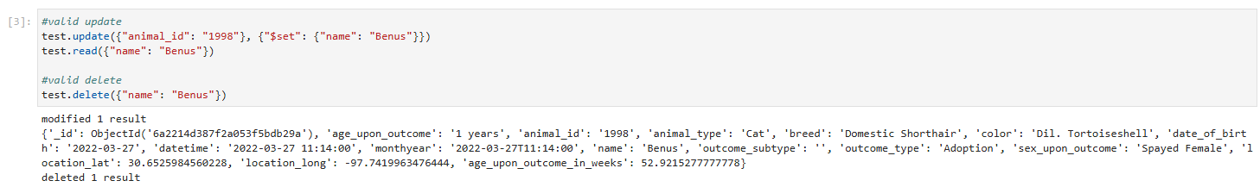

Screenshots
Importing the CSV file provided by AAC:
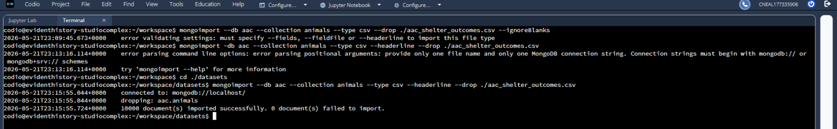

MongoSH login using AAC credentials:
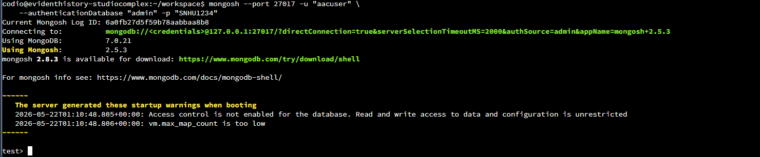

Roadmap/Features (Optional)
I plan to adjust the create and read functions to be more general, which will increase general usability. Delete and Update functions will also be added to complete CRUD functionality.

Contact
Your name: Cielo Neal

